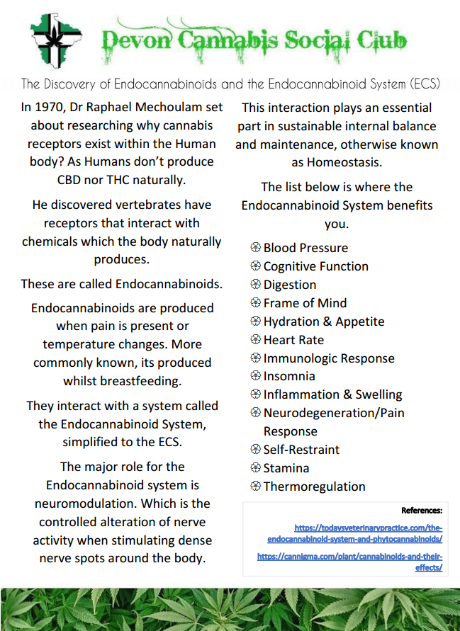

**Contents**

* 1. Glaucoma and Intraocular Pressure
  2. Dexanabinol (HU-211)

2.1 Macular Degeneration and Vascular Endothelial Growth Factor  
2.2 Diabetic Retinopathy and the Macula  
2.3 Age-Related Macular Degeneration

3.1 Corneal Vasodilation

4.1 Endocannabinoids and Retinal Homeostasis  
4.2 Prostamides Relationship with Receptors

5.1 Can Cannabis help with Cataracts?

6.1 Conclusion

The potential medical benefits of cannabis are expanding year by year. With what was suspected to be over 100 isoprenoids now developed into a suspected 1000 plus it is understandable as to how modern-day medicinal use develops, parallel to the science.

The following is from the abstract to Judith Booth’s, Terpene and Isoprenoid Biosynthesis in Cannabis Sativa: “Cannabis Sativa (cannabis, marijuana, hemp) is a plant species grown widely for its psychoactive and medicinal properties. Cannabis products were made illegal in most of the world in the early 1900s, but regulations have recently been relaxed or lifted in some jurisdictions, notably Canada and the United States. Cannabis is usually grown for the resin produced in trichomes on the flowers of female plants. The major components of that resin are isoprenoids: cannabinoids, monoterpenes and sesquiterpenes. Terpene profiles in cannabis flowers can vary widely between cultivars.”

The following is from the abstract to Endocannabinoids in the Retina: From Marijuana to Neuroprotection, found at the National Library of Medicine, “The active components of the Marijuana plant, Cannabis Sativa, Delta 9 Tetrahydrocannabinol (THC) produces numerous beneficial effects including analgesia, appetite stimulation and nausea reduction, in addition to its psychotropic effects.” In this article it is also noted “There is a great interest in endocannabinoids for their role in neuroplasticity as well as for therapeutic use in numerous conditions, including pain, stroke, cancer, obesity, osteoporosis, fertility, neurodegenerative diseases, multiple sclerosis, glaucoma and anti-inflammation, among others.” After extensive reading of their “Cannabinergic” introduction, I will attempt to share a morsel of their findings here, amongst others.

1.1 Glaucoma and Intraocular Pressure

Cannabis clinical trials are showing that cannabinoids can reduce intraocular pressure, otherwise known as IOP. The National Library of Medicine has a piece which states this is true whether the cannabinoids are administered orally, intravenously or via inhalation, “but not when they are applied directly to the eye”. Furthermore, “smoked or eaten, THC and synthetic cannabinoids in pill form and intravenous injections of several natural cannabinoids have all been shown to reduce IOP significantly in both Glaucoma and healthy adults with normal IOP”.

“In most trials a single dose of marijuana or cannabinoid maintained this effect for 3 - 4 hours”. The short duration of the effect means that Cannabis-Based Products for Medical use (CBPMs) should be taken up to eight times a day, which most are unlikely to achieve. “This is important because patients need to control IOP continuously due to the progressive nature of glaucoma”.

1.2 Dexanabinol (HU-211)

The National Library of Medicine continue to state “It is possible that future research could reveal a therapeutic effect for isolated cannabinoids other than THC or produce synthetic cannabinoid analogues that last longer and have fewer side effects” a cannabinoid that interacts with the same receptors as that of its naturally-comparable cannabinoid predecessor and is fine-tuned by mankind. “The most promising line of research for treating glaucoma lies in the development of therapies that can protect or rescue the optic nerve from damage or that can restore its blood supply. There is some evidence that a synthetic cannabinoid like compound known as HU-211 has nerve protecting properties, although it does not reduce IOP. HU-211 is chemically similar to THC, but it is not found in the marijuana plant and does not bind to the cellular receptor in the brain cells that THC activates.”

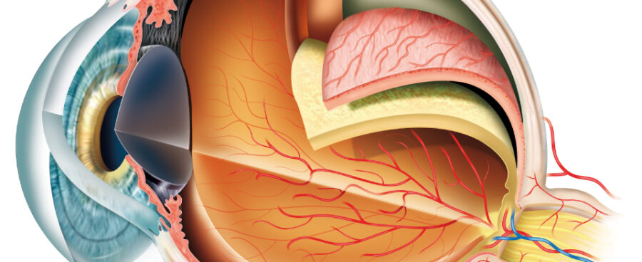HU-211, otherwise known as Dexanabinol is an “artificially synthesized cannabinoid lacking in cannabimimetic effects”, meaning it has similar pharmacological effects to that of cannabis. Dexanabinol is an antioxidant, anti-inflammatory and also has neuroprotective properties. It can help ensure the integrity of the blood brain barrier, alongside reducing cell apoptosis. Dexanabinol is “widely used in head treatments or stroke treatment and has shown to be safe in animals and humans”.

2.1 Macular Degeneration and Vascular Endothelial Growth Factor

Macular degeneration is the leading cause for sight loss in the United States and United Kingdom affecting more than 10 million in the US and nearly 1.5 million people here. Macular Degeneration, or MD, is deterioration of the central retina, in what is known as the “Macula”, giving the diagnosis its name. The Macula “records imagery and sends it to the brain. It’s in charge of focusing vision and helps humans read, recognise faces and many more important things. Without a functioning Macula, the center of the field of vision is blurry.” A potential cause of MD is “VEGF, or Vascular Endothelial Growth Factor”, which “can cause abnormal blood vessel growth around the eye”.

Tetrahydrocannabinol (THC) and Cannabidiol (CBD), have properties that studies have shown can slow down or block the causes of macular degeneration, including VEGF pathways.

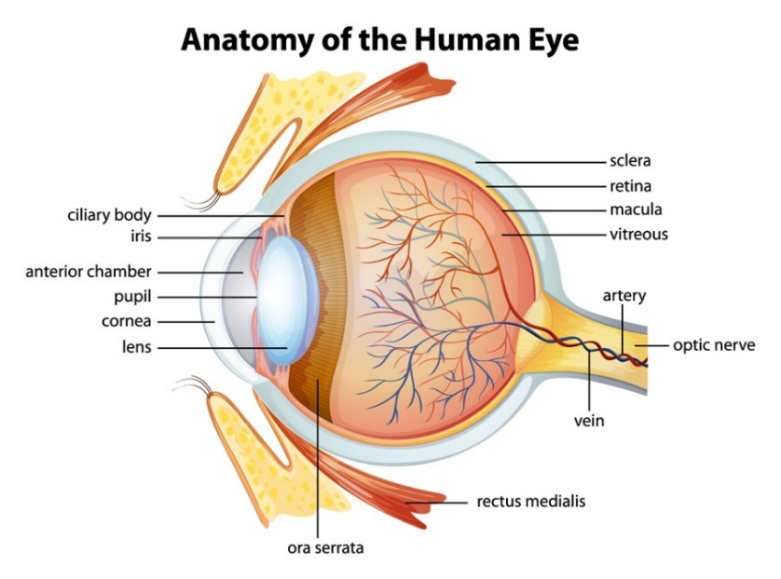2.2 Diabetic Retinopathy and the Macula

A study in 2008, “showed that CBD can block “diabetes and endotoxin induced retinal damage”, which includes macular degeneration” in addition to glaucoma. “CBD can also reduce cytokines, which are proteins that cause inflammation. These proteins can cause retinal thickening and aid in the degeneration of the Macula.” Previous studies dating back to 2004 also showed THC to be an effective cannabinoid for blocking the VEGF pathways when dealing with brain tumours.

According to the National Eye Institute (NEI) in America, diabetic retinopathy can reap significant prevention. As cannabis, in particular cannabidiol, CBD, can provide protection; Dr G. I. Liou “A compound found in marijuana won’t make you high but it may help keep your eyes healthy if you’re a diabetic…Early studies indicate cannabidiol works as a consummate multi-tasker to protect the eye from growing a plethora of leaky blood vessels, the hallmark of diabetic retinopathy”.

2.3 Age-Related Macular Degeneration

Topical reporting by S. Lehrer and P.H. Rheinstein on “Cannabis smoking and age-related macular degeneration in the UK Biobank cohort” concluded; “Drusen, deposits of lipids, proteins and cellular debris” which are typically first detected in the optic disk. “Accumulate in Bruch’s membrane, limiting transportation between the retinal pigment epithelium and the vasculature, triggering anti-inflammatory reaction”. Cannabis can essentially distort the inflammatory procedure, due to strong anti-inflammatory properties. Thereby, cannabis “could reduce the risk of AMD”. However, blood vessels situated in the eye below Bruch’s membrane, in what is called the “choriocapillaris”, becomes dispersed as people age. It is believed this is a starting point for age-related macular degeneration, AMD. Cannabis can “accelerate the loss of blood vessels due to its anti-angiogenic properties. Therefore, marijuana use might cause AMD to develop sooner in younger people”.

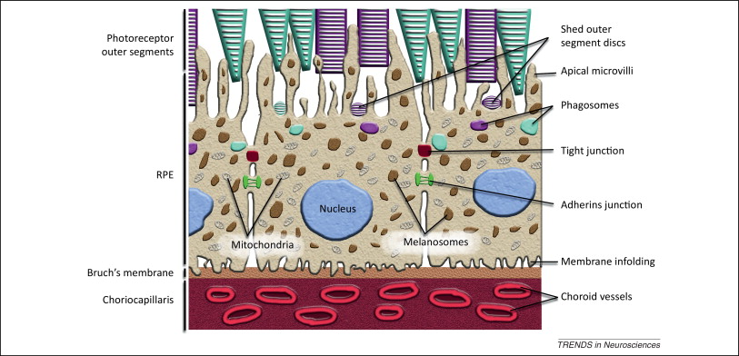

3.1 Corneal Vasodilation

For some time, people have referred to the red discolouration to the eyes caused by cannabis, as “red-eye”. In medicinal science, is what’s known as “corneal vasodilation”. Where by, the blood vessels inside of the cornea become dilated. Systemic response appears to widen the arteries to improve arterial flow over time, by itself as effects subside. However, “The popular idea that marijuana dilates the pupils s has not been supported by experimental data” and topical research into other parts, specifically in the eye, evade me at this time; such as the iris, retina etc.



4.1 Endocannabinoids and Retinal Homeostasis

The National Library for Medicine reported that having the presence of varying endocannabinoid degrading enzymes, provided “a broad spectrum of opportunity for basic research and to identify targets for therapeutic application to retinal diseases.” The eye very much has an endocannabinoid all of its own and has “much in common with the other regions of the central nervous system. For example, there is general agreement that cannabinoids contain dopamine release and presynaptically reduce transmitter release from cones and bipolar cells”.

Initially, it was theorised that cannabis “exerted its effects systemically through the central nervous system. It is now clear that the effects of THC and other cannabinoids reduce intraocular pressure (IOP) by local action non CB1 receptors in the eye.

“Physiology and Biochemical studies show that the presence of endocannabinoids and their effects on ocular tissues, including the ciliary, body, iris, choroid and trabecular meshwork in porcine, bovine, monkey and human tissues. The content of endocannabinoids, varies in certain disease states, suggesting the importance of endocannabinoids in maintaining ocular homeostasis. For example, 2-AG levels were found to decrease in the ciliary body of patients with glaucoma. However, the eyes of patients with diabetic retinopathy showed higher levels of 2-AG only in the iris”. Anandamide, otherwise known as AEA, held widespread vocation in the eye, with notably higher levels in an eye; retina, choroid, ciliary, body and cornea. When topically applied anandamide, AEA, reduces intraocular pressure by activating CB1 and EP2 receptors. This follows from the conversion of anandamide to prostamides.

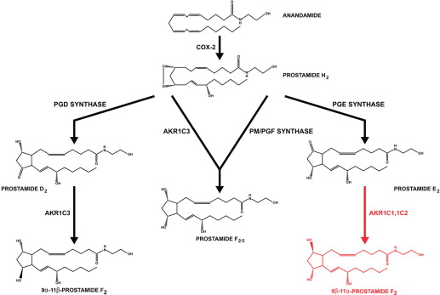4.2 Prostamides Relationship with Receptors

Prostamides are a “large and continually expanding series of pharmacologically unique neutral lipids”, which derive from oxidised products of the endocannabinoid/endovanniloid anandamide. DF Woodward, Y Liang and AH-P Krauss reviewed “Prostamides (prostaglandin-ethanolamides) and their pharmacology “By virtue of its close relationship to the anti-glaucoma drug bimatoprost, prostamide F2alpha has received the greatest research attention”.

The activation of EP2 can create adenylyl cyclase, leading to increased cytoplasmic cAMP levels and activation of protein kinase A. Adenylyl cyclase is the enzyme required to synthesize cyclic AMP, cAMP. This in turn helps regulate “diverse physiological responses including sugar and lipid metabolism, olfaction, and cell growth and differentiation.”

5.1 Can Cannabis help with Cataracts?

The following consists of information ascertaining to cannabis use in those with cataracts. “To date, there is no direct evidence that cannabis can help with cataracts. In fact, recent evidence shows smoking cannabis is linked to developing cataracts at a younger age, about 4-5 years earlier than expected.”. Smoke contains carcinogens regardless of whether it is from tobacco, or cannabis. Direct interaction could be harmful so smoking of any kind should be avoided. “It may be possible for forms of cannabis ingestion other than smoking could be beneficial for other aspects of cataracts, but at this stage that is only generalised and direct research is lacking”.

THC may still have its uses “While there is no conclusive evidence that medical cannabis can adequately treat cataracts, it has been proven to reduce inflammation and pain which are apparent in the condition and after surgery”. “Cannabinoids are known anti-inflammatory agents, more potent than vitamin C or E” it has shown effect in studies whereby cannabis has “alleviated some side effects of pressure and pain in many parts of the body, including temporarily reducing eye pressure for 3-4 hours with THC”. It is noted that “pure CBD, on the other hand, can actually raise eye pressure”.

Conclusively, at this time, cannabis cannot be considered a viable option for use treating cataracts but could be an accompanying part of a post-operation treatment plan for pain management and fighting inflammation. “Surgery will always be recommended as a permanent and safe fix for cataracts and cannabis could potentially be useful for managing the pain and pressure based on related data”. Currently, smoking anything appears to hold potential to lead to an earlier onset of cataracts.

Further details on transmitter release, ganglion cells, bipolar cells, transmission onto cones, cone light response, photoreceptors and cannabinoid receptors; can be found by reading Stephen Yazulla’s, Endocannabinoids in the retina: From Marijuana to Neuroprotection.

6.1 Conclusion

There are clear indications that cannabis could positively help, when treating or, as a preventative to retinal disease. With endocannabinoids being able to positively interact with the eyes, providing reductions of harmful protein growth, the potential of care plans being orchestrated in coherence with cannabis-based products. It is also very clear that with regards to integrating cannabis into a care plan, individuals should always consult with their doctor and professionals, or specialists, in the field such as an optometrist.



**Bibliography**

URL links:

<https://www.ncbi.nlm.nih.gov/books/NBK224386/#:~:text=Several%20clinical%20studies%20have%20found,do%20most%20conventional%20glaucoma%20medications.&text=This%20is%20true%20whether%20the,applied%20directly%20to%20the%20eye>.

<https://open.library.ubc.ca/soa/cIRcle/collections/ubctheses/24/items/1.0394478>

<https://www.medchemexpress.com/dexanabinol.html>

<https://www.compassionatecertificationcenters.com/news/how-cannabis-slows-down-the-effects-of-macular-degeneration/>

<https://www.alensa.co.uk/dictionary/conjunctival-vasodilation.html>

<https://www.spandidos-publications.com/10.3892/ijmm.2018.3744>

<https://www.sciencedirect.com/topics/neuroscience/adenylyl-cyclase#:~:text=Adenylyl%20cyclase%20is%20the%20sole,and%20cell%20growth%20and%20differentiation>.

<https://bpspubs.onlinelibrary.wiley.com/doi/pdf/10.1038/sj.bjp.0707434>

<https://www.medicalnewstoday.com/articles/327402>

<https://www.ncbi.nlm.nih.gov/pmc/articles/PMC2584875/>

<https://www.sciencedirect.com/science/article/abs/pii/S0181551222001322>

<https://febs.onlinelibrary.wiley.com/doi/pdf/10.1111/j.1432-1033.2004.04081.x>

<https://www.sciencedirect.com/topics/medicine-and-dentistry/drusen>

<https://www.sciencedirect.com/science/article/abs/pii/S0181551222001322>

<https://www.sciencedirect.com/topics/neuroscience/olfaction>

<https://www.veriheal.com/conditions/cataracts/#:~:text=To%20date%2C%20there%20is%20no,5%20years%20earlier%20than%20expected>.

<https://www.medicalnewstoday.com/articles/316999?fbclid=IwAR02Zrjw0tubhbfwINQyUC8l2Z7BYDzC1PIUPSZCgrbPwxgQthyRH-umPiU#what-is-medical-marijuana>

<https://pubmed.ncbi.nlm.nih.gov/25843054/>

<https://www.marijuanadoctors.com/conditions/macular-degeneration/>

<https://diabetesjournals.org/care/article/39/10/1777/129/Efficacy-and-Safety-of-Cannabidiol-and?fbclid=IwAR1ZwgN2RxzsAlP0w8_-BCv3tUzKF2mckAZ8rPR3hJJqne6OJab6b3rYsC4>

<https://www.sciencedaily.com/releases/2006/02/060227184647.htm>

<https://www.ncbi.nlm.nih.gov/pmc/articles/PMC3083879/>

<https://www.drugscience.org.uk/medical-cannabis-compared-to-common-pain-medications/>

<https://pubmed.ncbi.nlm.nih.gov/31152633/>

<https://pubmed.ncbi.nlm.nih.gov/23684393/>

Literature:

Cannabinoids and Terpenes: The Medical Benefits of Cannabis - by Ryder Management Inc

Terpene and Isoprenoid Biosynthesis in Cannabis Sativa - by Booth Judith

Imagery:

<https://www.exetereye.co.uk/the-eye/eye-anatomy/>

<https://www.sciencedirect.com/science/article/abs/pii/S0166223613000532>

<https://medium.com/@zamnesia/how-to-prevent-and-treat-red-eyes-from-consuming-or-smoking-cannabis-85b59dc886f8>