* Muscle Cramping
* Gastrointestinal Pain
* Diabetic Retinopathy
* Blood Sugar Levels
* Arterial Inflammation
* Neuropathic Pain
* Blood Circulation
* Insulin Sensitivity
* Risks of Obesity

The potential medical benefits of cannabis are expanding year by year. With what was suspected to be over 100 isoprenoids now developed into a suspected 1000 plus it is understandable as to how modern-day medicinal use develops, parallel to the science.

With relation to Diabetes, both types 1 and 2, there is medicinal science to suggest there are benefits that can be found with cannabis in relation to:

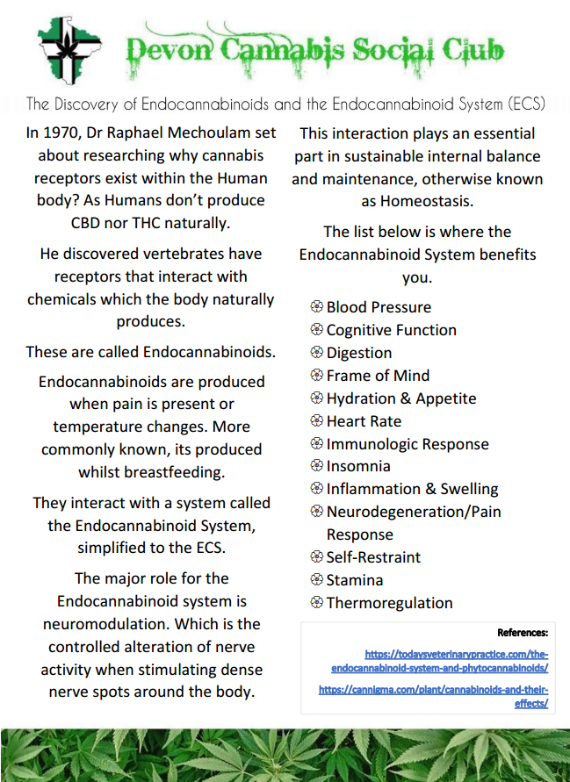



Studies by The Association of American Medical Colleges (AAMC) suggest that cannabis stabilises blood sugar levels, lowers arterial inflammation through its antioxidant properties, reduces neuropathic pain which is more often than not accompanying diabetes diagnosis, assists in keeping blood vessels open which may also reduce blood pressure over time further improving circulation. They further suggest it can provide relief from muscle and gastrointestinal cramping and pain. Researchers have compiled topical studies also suggesting that there is a reduced risk of obesity, which in particular is of significant risk to those diagnosed with type 2 diabetes. Individuals who use or consume cannabis may have increased insulin sensitivity, it has been noted that scientists observed fasting levels, in users, were lower than former and non-users or consumers. Insulin resistance levels amongst those taking cannabis were also lower on average.

In 2016, a study under the American Diabetes Association in relation to type 2 diabetes indicated that tetrahydrocannabinol (THC) helped to:

* Significantly drop fasting blood glucose.
* Improve production of insulin.
* Raise levels of adiponectin, a protein found in the body that can help regulate blood sugar levels.

Topical treatment can lead to a reduction in symptoms from those with peripheral neuropathic pain. People who seek medical advice, can apply cannabinoids to reduce pain and tingling sensations that are symptomatic of diabetic neuropathy.

*“People should always buy products from trusted suppliers and check with a Dr before applications or use to ensure they are safe first”*

For both types of diabetes, there are anti-inflammatory properties found within cannabis that can aid in treating inflammation caused by diabetes and also some of the associated complications.

According to the National Eye Institute (NEI) in America, Diabetic Retinopathy can reap significant prevention. As cannabis, in particular cannabidiol (CBD) can provide protection as quoted below;

Dr Gregory I. Liou – A compound found in marijuana won’t make you high but it may help keep your eyes   
 healthy if you’re a diabetic…Early studies indicate cannabidiol works as a consummate  
 multi-tasker to protect the eye from growing a plethora of leaky blood vessels, the  
 hallmark of Diabetic Retinopathy.

A study involving neuropathic foot pain sufferers, summarised; “inhaling cannabis can provide several hours of pain relief from diabetic neuropathic pain. Higher doses provided greater relief”.

Whilst there are many positives, in the efforts of unbiased topical compilation below are the noted and evaluated risks surrounding cannabis use with diabetes.

Cannabis use can lead to an increased appetite, more commonly referred to as “the munchies”. This may cause people to crave and eat large amounts of carbohydrates and/or artificial sugars. Cannabis can inhibit a person’s ability to make dietary choices.

An increased appetite, poses a particular risk to those with diabetes. When consuming carbohydrates the bodies blood sugar levels can spike. Very high levels can result in a medical emergency.

Other documented potential adverse effects include faster heart rate, breathing issues caused by apparatus misuse, dizziness, slower reaction times, advice on driving and heavy machinery use should be sought out before using cannabis for medicating.





**Bibliography**

URL links:

<https://www.medicalnewstoday.com/articles/316999?fbclid=IwAR02Zrjw0tubhbfwINQyUC8l2Z7BYDzC1PIUPSZCgrbPwxgQthyRH-umPiU#what-is-medical-marijuana>

<https://pubmed.ncbi.nlm.nih.gov/25843054/>

<https://diabetesjournals.org/care/article/39/10/1777/129/Efficacy-and-Safety-of-Cannabidiol-and?fbclid=IwAR1ZwgN2RxzsAlP0w8_-BCv3tUzKF2mckAZ8rPR3hJJqne6OJab6b3rYsC4>

<https://www.sciencedaily.com/releases/2006/02/060227184647.htm>

<https://www.ncbi.nlm.nih.gov/pmc/articles/PMC3083879/>

<https://www.drugscience.org.uk/medical-cannabis-compared-to-common-pain-medications/>

<https://pubmed.ncbi.nlm.nih.gov/31152633/>

<https://pubmed.ncbi.nlm.nih.gov/23684393/>

Literature:

Cannabinoids and Terpenes: The Medical Benefits of Cannabis - by Ryder Management Inc